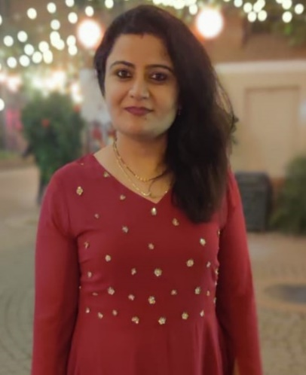**DR. GARIMA VERMA**

**Email:** [garimahansrajverma@gmail.com](mailto:garimahansrajverma@gmail.com)

**CURRENT AFFILIATION: Associate Consultant, HealthPlix Technologies, Bengaluru, Karnataka - 560103**

**EDUCATION:** PhD (Jamia Hamdard-2018);M. Pharm (Jamia Hamdard-2014); B. Pharm (PGIMS, Rohtak-2012)

**RESEARCH TITLE: Studies on Pyrazole based Antiprotozoal Compounds: Their Synthesis and Metabolic Evaluation**

**REGISTRATION NO:** 2012-528-003 **REGISTRATION DATE:** 09-09-2014

**SUPERVISOR: Dr. M. Shaquiquzzaman** **CO-SUPERVISOR-1: Dr. M. Mumtaz Alam**

**FELLOWSHIP:** UGC NET (2015 to 2018)

**PUBLICATIONS & PATENTS** (Google Scholar)**:**

**Number:** 30 (Till March, 2023) **Citations:** 1622 **h-index**: 16 **i-10:** 22 **i-100:** 05 **Patents:** 00

1. **Garima Verma**, Mohemmed Faraz Khan, Lalit Mohan Nainwal, Mohd Ishaq, Mymoona Akhter, Afroz Bakht, Tariq Answer, Farhat Afrin, Mohammad Islamuddin, Ibraheem Husain, Mohammad Mumtaz Alam, Mohammad Shaquiquzzaman, Targeting malaria and leishmaniasis: Synthesis and pharmacological evaluation of novel pyrazole-1,3,4-oxadiazole hybrids. Part II, (2019) *Bioorganic Chemistry*, 89, 102986. (Impact Factor: **5.27**). <https://www.sciencedirect.com/science/article/abs/pii/S0045206818315311>
2. **Garima Verma**, Gousia Chashoo, Asif Ali, Mohemmed Faraz Khan, Wasim Akhtar, Israr Ali, Mymoona Akhtar, Mohammad Mumtaz Alam, Mohammad Shaquiquzzaman (2018), Synthesis of pyrazole acrylic acid based oxadiazole and amide derivatives as antimalarial and anticancer agents, *Bioorganic Chemistry*, 77, 106-124. (Impact Factor: **5.27**) <https://pubmed.ncbi.nlm.nih.gov/29353728/>

**PROFESSIONAL EXPERIENCE:**

1. Associate Consultant, HealthPlixJuly 2022 - Present
2. Manager, DAVA India Operations, DAVA Oncology September 2020 – May 2022
3. Research Analyst Team Lead, DAVA Oncology August 2019 – September 2020
4. Research Analyst, DAVA Oncology February 2019 – August 2019

**SYMPOSIUM AND POSTER PRESENTATIONS: 05**

**BOOKS/ CHAPTERS/MONOGRAPHS/ PUBLISHED:** 02

1. **Garima Verma**, M Shaquiquzzaman, M Mumtaz Alam. Heterocyclic drugs design and development, Promising Drug Molecules of Natural Origin, Apple Academic Press. 2020. <https://www.appleacademicpress.com/promising-drug-molecules-of-natural-origin-/9781771888868>
2. M M Alam, M Akhter, M. Shaquiquzzaman, **Garima Verma** (**2019**): Pharmaceutical Chemistry-I, *S R Health Sciences Private Limited*.

**COURSES & CERTIFICATIONS**

1. cGMP: Introduction to Good Manufacturing Practice – An Abridged Course, Biopharma Institute, May 2020.
2. Collaborative Institutional Training Initiative (CITI), April 2020

* CITI Good Clinical Practice
* Health Information Privacy and Security (HIPS)

1. Clinical Research Professional Development Program, Kriger Research Center, October 2019

* Clinical Trial Monitoring and Research Site Coordination
* The International Conference on Harmonization (ICH)
* Good Clinical Practice (GCP) Guidelines

**PROFESSIONAL CREDENTIALS:**

**Scopus ID:** 57823408200 **ORCID ID:** 0009-0001-5215-5026 **LinkedIn:** <https://www.linkedin.com/in/garima-verma-68ba8b77>

**PROFESSIONAL MEMBERSHIP OF SOCIETIES:** Life Member, Indian Pharmacy Graduates’Association (IPGA)

**CONTACT DETAILS: Mobile:** +91-8800350564 **Email:**[garimahansrajverma@gmail.com](mailto:drmmalam@gmail.com)

|  |  |
| --- | --- |
| Jamia Hamdard - Wikipedia |  |